Pre-Requisite

1.IBM Cloud Services

|  |  |
| --- | --- |
| Date | 9th Nov 2022 |
| Roll no | 720719106040 |
| Project name | Project-Real Time River  Water Quality Monitoring And Control System |
| Maximum Marks | 2 Marks |

**IBM cloud services:**

**The IBM cloud services are used to handle the cloud storage and function the data.**

**IBM cloud services:**

**Launch the cloud**

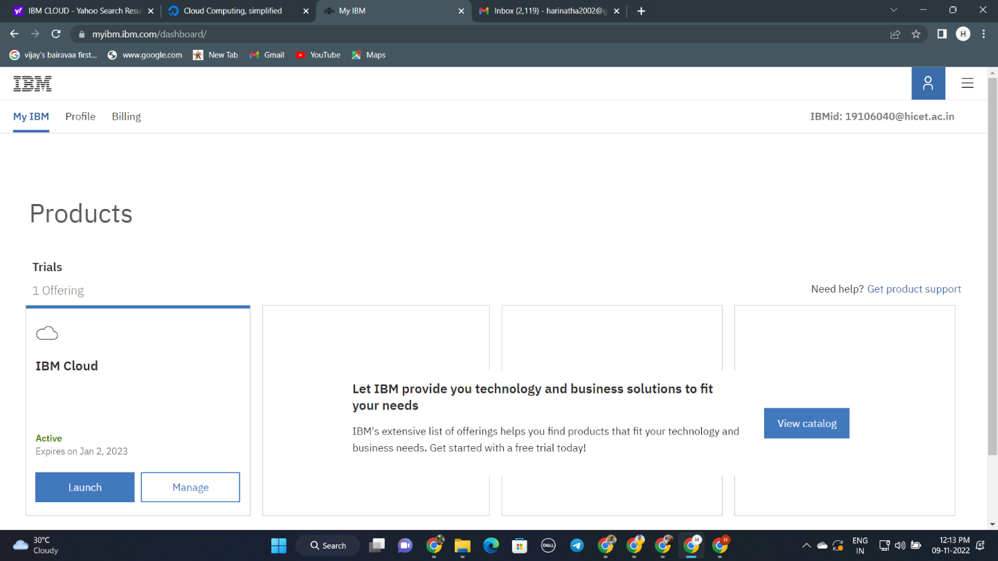

IBM cloud has been created:

